**Assignment -1**

Python Programming

|  |  |
| --- | --- |
| Assignment Date | 19 September 2022 |
| Student Name | A ARUL JESHIN |
| Student Roll Number | 111519205001 |
| Maximum Marks | 2 Marks |

Develop a sample homepage with html, CSS which should include banner, image & description about yourself and contact form.

**Index.html:**

<!DOCTYPE html>

<html>

<head>

    <title></title>

    <link rel="stylesheet" type="text/css" href="style.css">

    <link href="https://fonts.googleapis.com/icon?family=Material+Icons" rel="stylesheet">

</head>

<body>

<div class="main">

    <div class="left">

        <br>

        <div class="profile-img"><img src="image1.png"></div>

        <div class="box-1">

            <div class="heading">

                <p>CONTACT</p>

            </div>

            <p class="p1"><i class="material-icons icons1">call</i>+91 1234567890</p>

            <p class="p1"><i class="material-icons icons1">email</i>assign1@gmail.com</p>

        </div>

        <div class="box-1">

            <div class="heading">

                <p>LANGUAGES</p>

            </div>

            <p class="p1">HTML

            <div class="skill-container">

                <div class="skill html"></div>

            </div>

            </p>

            <p class="p1">CSS

            <div class="skill-container">

                <div class="skill css"></div>

            </div>

            </p>

            <p class="p1">PYTHON

            <div class="skill-container">

                <div class="skill js"></div>

            </div>

            </p>

            <p class="p1">C PROGRAMMING

            <div class="skill-container">

                <div class="skill jquery"></div>

            </div>

            </p>

        </div>

        <br>

        <div class="box-1">

            <div class="heading">

                <p>SKILLS</p>

            </div>

            <p class="p1">WEB DEVELOPMENT

            <div class="skill-container">

                <div class="skill web"></div>

            </div>

            </p>

            <p class="p1">DBMS

            <div class="skill-container">

                <div class="skill gra"></div>

            </div>

            </p>

        </div>

        <br>

        <div class="box-1">

            <div class="heading">

                <p>HOBBIES</p>

            </div>

            <div class="h-div">

                <i class="material-icons icons2">camera_roll</i>

                <i class="material-icons icons2">music_note</i>

            </div>

        </div>

    </div>

    <div class="right">

        <div class="name-div">

            <h1>ARUL JESHIN</h1>

            <p><u>IT STUDENT</u></p>

        </div>

        <div class="box-2">

            <h2>ABOUT ME <i class="material-icons icons3" style="font-size: 28px!important; ">perm_identity</i></h2>

            <p class="p2">

                Lorem Ipsum is simply dummy text of the printing and typesetting industry. Lorem Ipsum has been the industry's standard dummy text ever since the 1500s,<br> when an unknown printer took a galley of type and scrambled it to make a type specimen book. It has survived not only five centuries,

            </p>

        </div>

        <div class="box-2">

            <h2>EDUCATION <i class="material-icons icons3" >border_color</i></h2>

            <p class="p3">2017-2018 <span>Lorem Ipsum is simply dummy</span></p>

            <p class="p2">

                Lorem Ipsum is simply dummy text of

            </p>

<p class="p3">2018-2019 <span>Lorem Ipsum </span></p>

            <p class="p2">

                Lorem Ipsum is simply dummy text of

            </p>

            <p class="p3">2019-2023 <span>Lorem Ipsum is</span></p>

            <p class="p2">

                Lorem Ipsum is simply dummy text of

            </p>

        </div>

        <div class="box-2">

            <h2>WORK EXPERIENCE <i class="material-icons icons3" >folder</i></h2>

            <p class="p3">2022 <span>Lorem Ipsum is simply dummy</span></p>

            <p class="p2">

                Lorem Ipsum is simply dummy text of

            </p>

            <p class="p3">2023 <span>Lorem Ipsum </span></p>

            <p class="p2">

                Lorem Ipsum is simply dummy text of

            </p>

        </div>

    </div>

</div>

</body>

</html>

**Style.css:**

@import url('https://fonts.googleapis.com/css2?family=Montserrat&display=swap');

body{

    background-image: linear-gradient(#c8e6d5, #d3e7da);

    height: 122vh;

    font-weight: bold;

    letter-spacing: 2px;

}

*{

    margin: 0px; padding: 0px; font-family: 'Montserrat', sans-serif;

}

.main{

    background-color: #ffffff;

    height: auto;

    width: 650px;

    position: absolute;

    transform: translate(-50%, -50%);

    left: 50%;

    top: 60%;

}

.left{

    background-color: #39e75f;

    width: 200px;

    height: 100%;

    float: left;

}

.right{

    width: 450px;

    float: left;

}

.profile-img{

    height: 180px;

    width: 180px;

    background-color: #ddd;

    border-radius: 50%;

    margin-bottom: 20px;

    margin-left: 60px;

    border: 10px solid #39e75f;

}

.profile-img img{

    width: 100%;

    border-radius: 50%;

}

.box-1{

    position: relative;

}

.heading{

    background-color: #000000;

    padding: 10px;

    color: #39e75f;

    text-align: left;

    padding-left: 20px;

    margin-right: -15px;

}

.heading::after{

    content: '';

    position: absolute;

    width: 21px;

    height: 18px;

    background-color: #000000;

    left: 191px;

    top: 26px;

    transform:rotate(56deg);

    z-index: -1;

}

.p1{

    padding: 9px 10px;

    font-size: 11px;

}

.icons1{

    font-size: 16px!important;

    padding-right: 10px!important;

    vertical-align: sub;

}

.skill-container{

    width: 90%;

    background-color: #000000;

    margin: 0px 10px;

}

.skill{

    text-align: right;

    padding-top: 2px;

    padding-bottom: 2px;

    color: white;

}

.html{

    width: 90%;

    background-color: white;

}

.css{

    width: 80%;

    background-color: white;

}

.js{

    width: 85%;

    background-color: white;

}

.jquery{

    width: 80%;

    background-color: white;

}

.web {

    width: 85%;

    background-color: white;

}

.gra{

    width: 70%;

    background-color: white;

}

.icons2{

    padding: 18px 10px;

}

.name-div{

    padding: 86px 0px 60px 55px;

    text-align: center;

    letter-spacing: 3px;

}

.name-div h1{

    margin-bottom: 10px;

}

.box-2{

    padding: 0px 50px;

    margin-top: 30px;

}

.p2{

    font-size: 10px;

    font-weight: 300;

    letter-spacing: 1px;

    word-spacing: 2px;

    line-height: 18px;

    margin-top: 5px;

}

h2{

    font-size: 16px;

    margin-bottom: 15px;

}

.icons3{

    vertical-align: bottom;

    font-size: 21px!important;

    color: #000000;

}

.p3{

    font-size: 13px;

    word-spacing: 1px;

    letter-spacing: 0px;

    margin-top: 10px;

}

.p3 span{

    color: #39e75f; padding-left: 20px;

}

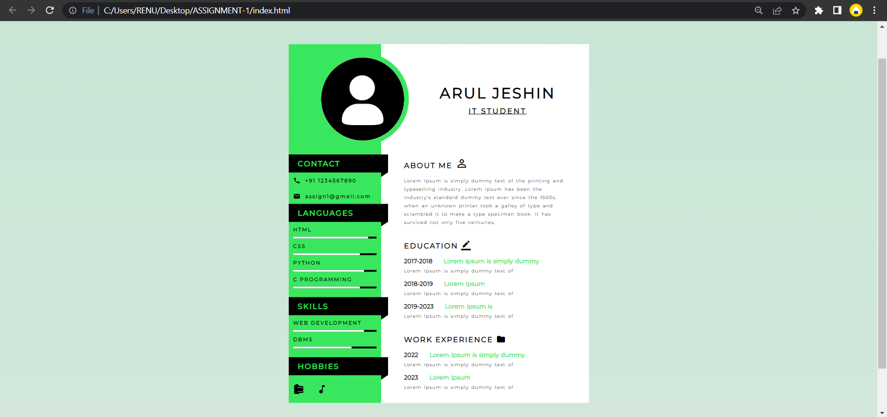**OUTPUT :**